Learning Management System Reports Job Aid
Contents
Background 3
Your Tasks 4
Accessing the Administrative Menu 5
HCSIS Reports 8
1. Attendance Report 8
2. Capacity Seats 9
3. Capacity Users Registered 9
4. Class Roster 10
5. Class Roster with User Passwords 11
6. Course and Roles 12
7. Course Requirements 13
8. Duplicate Users 14
9. Email List by Course 15
10. Email List by Training Role 16
11. Enrollment Report 17
12. Evaluation Summary – Rate 18
13. Evaluation Summary – Text 19
14. Evaluation by Course – Rate 20
15. Evaluation by Course – Text 21
16. Evaluation by Instructor – Rate 22
17. Evaluation by Instructor – Text 24
18. Registration for Allocated Classes 25
19. Scheduling Report 26
20. Transcripts - Personal 27
21. Transcripts for Entity Personnel 27
22. User and Roles Report 28
Investigations Program Reports 30
1. Certification Management 30
2. Certification Investigation (CI) All Users 31
3. CI Applicants Who Failed Report 32
4. CI Attempt Statistics 33
5. CI Attendance Reports 34
6. CI Course and Roles 35
7. CI Course Requirements 36
8. CI Enrollment Report 37
9. CI Roster (Course) Report 38
10. CI Roster (Exam) Report 39
11. CI Scheduling 40
12. CI Session Statistics 41
Quality Management Reports 43
1. Attendance Report 43
2. Class Roster 44
3. Class Roster – Additional Information 45
4. Course and Roles 46
5. Email List by Course 47
6. Email List by Training Role 48
7. Enrollment Report 49
8. Scheduling Report 50
9. User and Roles Report 51
Supports Coordination Reports 53
1. Attendance Report 53
2. Class Roster 54
3. Class Roster – Additional Information 55
4. Course and Roles 56
5. Email List by Course 57
6. Email List by Training Role 58
7. Enrollment Report 59
8. Scheduling Report 60
9. User and Roles Report 61

Background

The Home and Community Services Information System (HCSIS) project is using a Learning Management System (LMS) to assist in training logistics, including course registration and tracking attendance. After the end user role information is returned to the project (through the Role Tracking Tool or Provider Sign Up), it is loaded into the LMS. The LMS will send out an email to the end users identified. The email will contain a user ID, password, and instructions on how to access the LMS.

This document has been created to assist users with the reports offered on the LMS.

For each report, a brief description is provided along with the organization of the output, the data elements, an explanation of the mandatory and optional parameters to help you get the results you want, and the roles that have access to each report. If a particular report is not displayed on your screen, it means you don’t have access to run that report.

Your Tasks

As a registrar, you can perform the following tasks:
Task | Page Number

Access the Admin Menu

Access Reports by clicking on the Reports hyperlink

Select Training Type

Select Report Type

View Report

Detailed instructions are included in this job aid packet. The documentation for each task is divided into the following sections:
Section | Use
Procedure Description | This is a brief summary of the purpose of the screen. It includes the context of this screen within the process.
Dependencies | The steps that precede the start of a procedure.
Steps | This describes the steps for completing the procedure.

Accessing the Administrative Menu

Procedure Description:

Use this link to access the LMS home-page screen.

Dependencies:
- You will not have access to the Instructor Tools until the System Administrator has assigned you the security role of Instructor.
- You must log onto the LMS in the following location: http://www.humanservices-r.state.pa.us/HCSISLMS

Steps:
- Log in to the LMS.

- Click on Admin Menu to access the next screen.

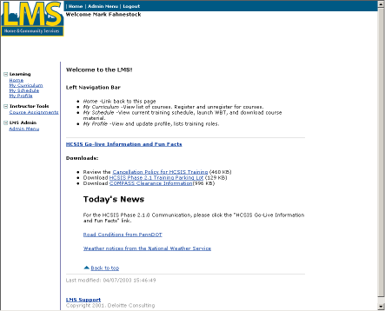
Accessing the Administrative Menu, Continued

- The following screen displays:

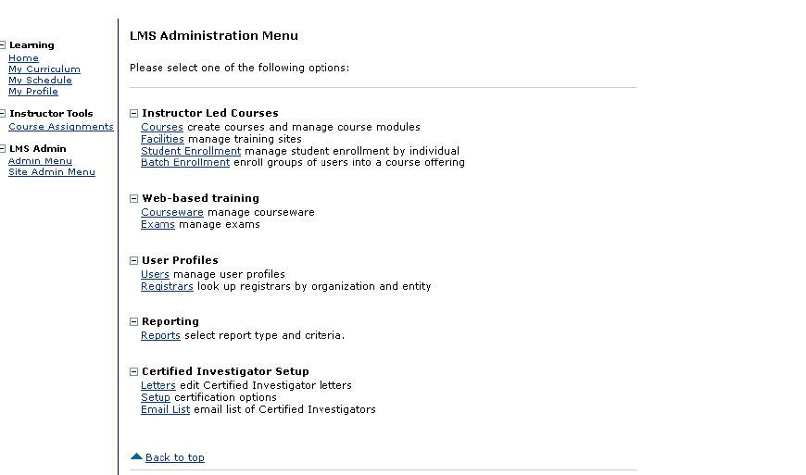
- Click on Reports.
- The following screen displays:

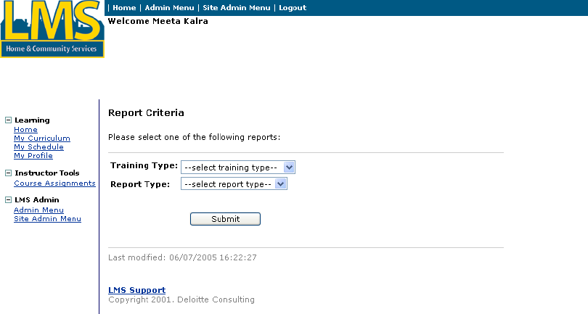

- To select a report, select an option from the Training Type drop-down menu box

Accessing the Administrative Menu, Continued
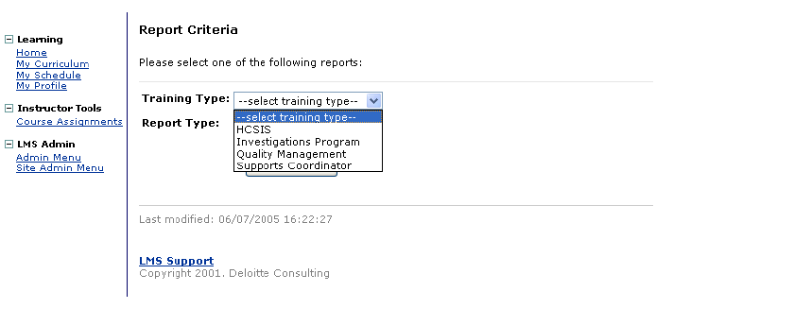
- Next, use the Report Type drop-down menu box to select a report type.

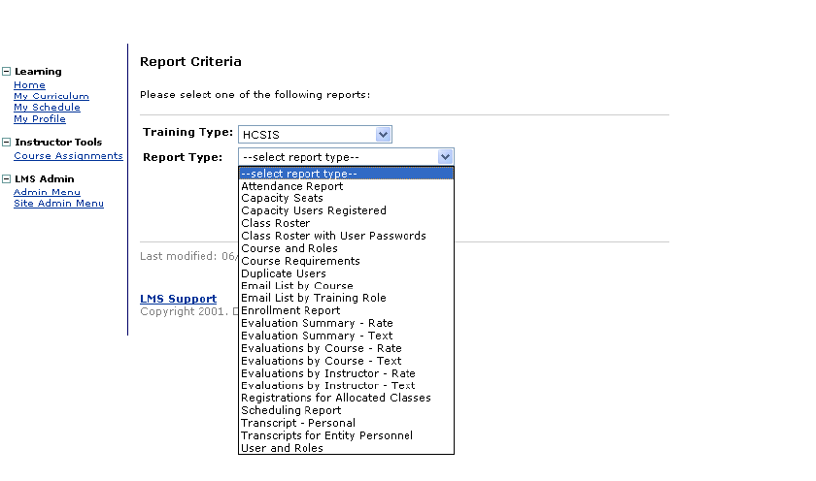
Tip:

The options available will depend on the Training Type in the previous field.

- Click [Submit].

HCSIS Reports

1. Attendance Report
This report provides information about the individuals who have registered for a particular course offered on the LMS.

HCSIS roles that can access the Attendance Reports:
- Registrar
- Instructor
- Systems Administrator

The search parameters are:

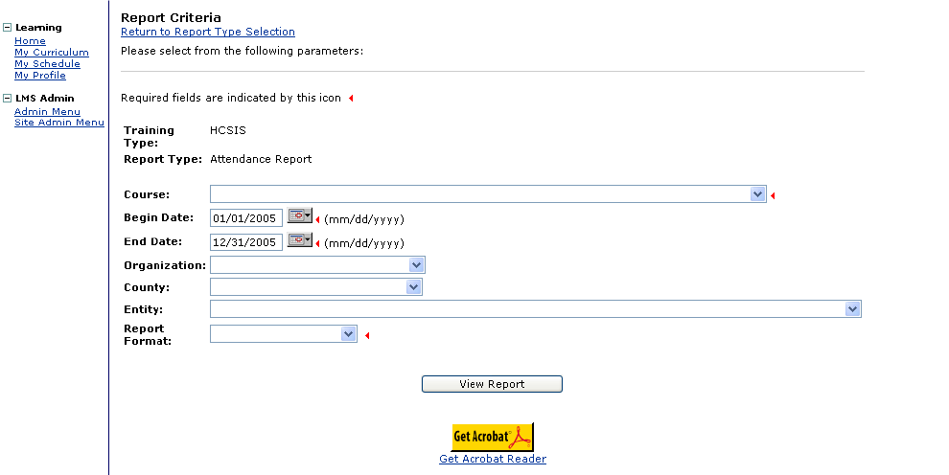

Parameter | Description | Mandatory or Optional
Course | Select from the drop-down list to limit the results to display attendance only for the course selected | Mandatory
Begin & End Dates | Enter a date span to limit the results to a period | Optional
Organization | Select from the drop-down list, if desired | Optional
County | Select the county from the drop-down list, if desired. | Optional
Entity | Select the entity from the drop-down list, if desired | Optional
Report Format | Select how the report should appear from the list:  Rich text format and Adobe Acrobat (PDF) – display report results with graphics and a user-friendly layout. Plain text – displays report results without graphics and a standard layout | Mandatory

HCSIS Reports, Continued

2. Capacity Seats
This report provides information about the number of available seats for a particular course offered on the LMS.

HCSIS roles that can access this report:
- Registrar
- Instructor
- Systems Administrator

The search parameters are:

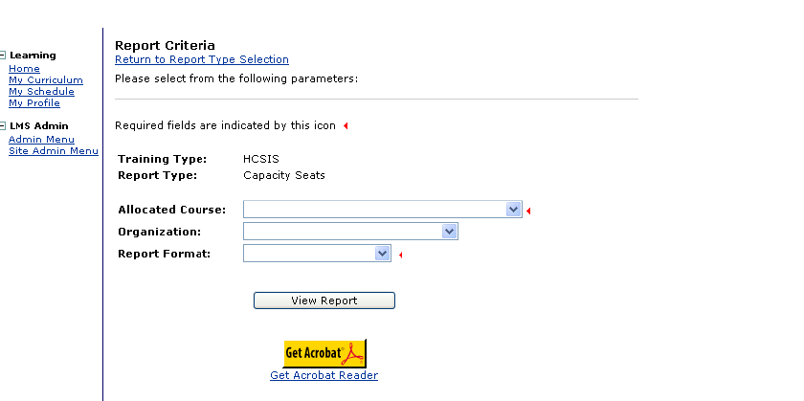

Parameter | Description | Mandatory or Optional
Allocated Course | Select the course from the drop-down list | Mandatory
Organization | Select from the drop-down list, if desired | Optional
Report Format | Select how the report should appear from the list:  Rich text format and Adobe Acrobat (PDF) – display report results with graphics and a user-friendly layout. Plain text – displays report results without graphics and a standard layout | Mandatory

3. Capacity Users Registered
This report provides information about the number of participants registered versus the total number of seats allocated per county/ entity for a particular course offered on the LMS.

HCSIS Reports, Continued

HCSIS roles that can access this report:
- Registrar
- Instructor
- Systems Administrator
The search parameters are:

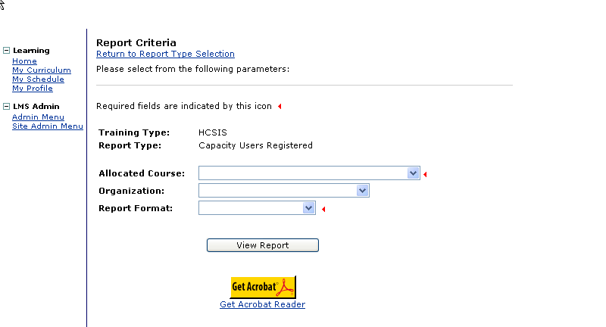

Parameter | Description | Mandatory or Optional
Allocated Course | Select the course from the drop-down list | Mandatory
Organization | Select the name of the organizing entity from the drop-down list, if desired | Optional
Report Format | Select how the report should appear from the list:  Rich text format and Adobe Acrobat (PDF) – display report results with graphics and a user-friendly layout. Plain text – displays report results without graphics and a standard layout | Mandatory

4. Class Roster
This report provides a list of all registered participant names, their login ID and County for a particular course offered on the LMS.

HCSIS Reports, Continued
HCSIS roles that can access this report:
- Registrar
- Instructor
- Systems Administrator

The search parameters are:
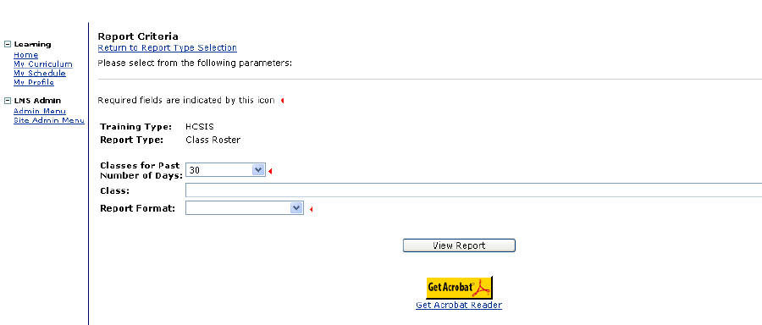
Parameter | Description | Mandatory or Optional
Classes for Past Number of Days | Select the number of days for how far back you wish to search for a class offered on the LM S | Mandatory
Class | The system will display all classes offered for the time period selected in the first field. Select the name of the class from the drop-down list. | Mandatory
Report Format | Select how the report should appear from the list:  Rich text format and Adobe Acrobat (PDF) – display report results with graphics and a user-friendly layout. Plain text – displays report results without graphics and a standard layout | Mandatory

5. Class Roster with User Passwords
This report provides a list of all registered participant names, login ID, LMS passwords and respective Counties for a particular course offered on the LMS.

HCSIS roles that can access this report:
- Registrar
- Instructor
- Systems Administrator
HCSIS Reports, Continued
The search parameters are:
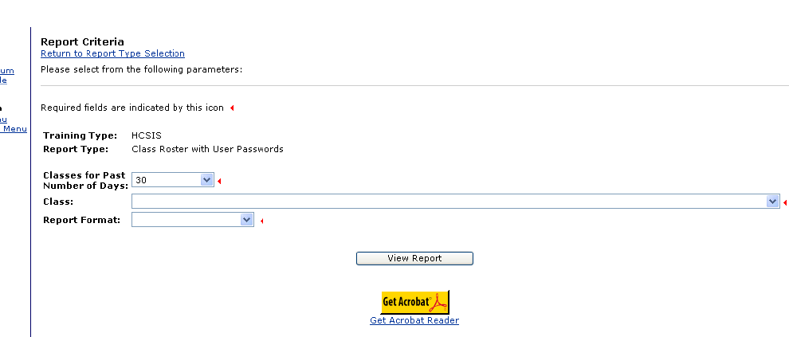
Parameter | Description | Mandatory or Optional
Classes for Past Number of Days | Select the number of days for how far back you wish to search for a class offered on the LM S | Mandatory
Class | The system will display all classes offered for the time period selected in the first field. Select the name of the class from the drop-down list. | Mandatory
Report Format | Select how the report should appear from the list:  Rich text format and Adobe Acrobat (PDF) – display report results with graphics and a user-friendly layout. Plain text – displays report results without graphics and a standard layout | Mandatory

6. Course and Roles
This report provides a list of all courses offered on the LMS and the roles for whom the course is available.

HCSIS roles that can access this report:
- Logistics Manager
- Registrar
- Instructor
- Systems Administrator

HCSIS Reports, Continued
The search parameters are:
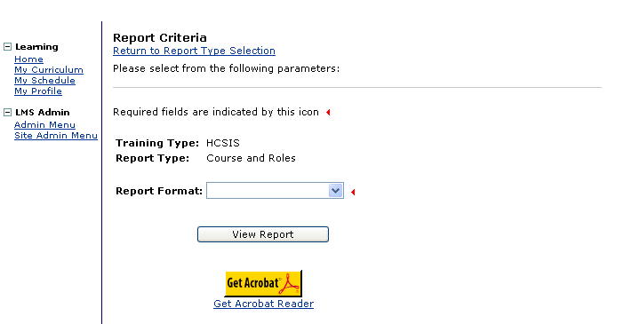
Parameter | Description | Mandatory or Optional
Report Format | Select how the report should appear from the list:  Rich text format and Adobe Acrobat (PDF) – display report results with graphics and a user-friendly layout. Plain text – displays report results without graphics and a standard layout | Mandatory

7. Course Requirements
This report provides an alphabetical list of all participants and the prerequisite modules each registered participant has completed prior to enrolling for the current course.

HCSIS roles that can access this report:
- Registrar
- Instructor
- Systems Administrator

HCSIS Reports, Continued
The search parameters are:
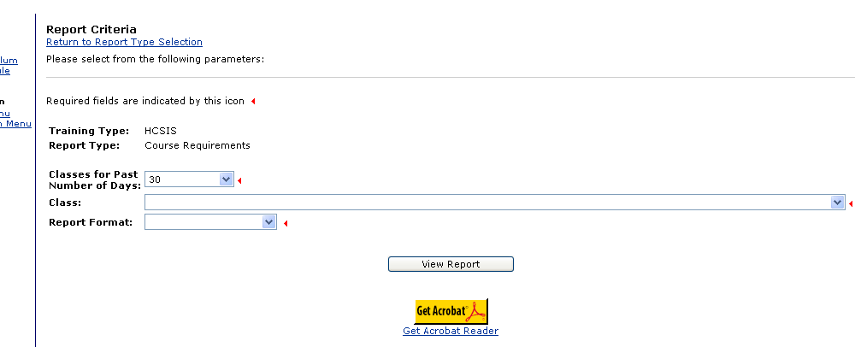
Parameter | Description | Mandatory or Optional
Classes for Past Number of Days | Select the number of days for how far back you wish to search for a class offered on the LM S | Mandatory
Class | The system will display all classes offered for the time period selected in the first field. Select the name of the class from the drop-down list. | Mandatory
Report Format | Select how the report should appear from the list:  Rich text format and Adobe Acrobat (PDF) – display report results with graphics and a user-friendly layout. Plain text – displays report results without graphics and a standard layout | Mandatory

8. Duplicate Users
This report provides list by organization of all individuals who have more than one login ID for the LMS.

HCSIS roles that can access this report:
- Logistics Manager
- Registrar
- Instructor
- Systems Administrator

HCSIS Reports, Continued
The search parameters are:
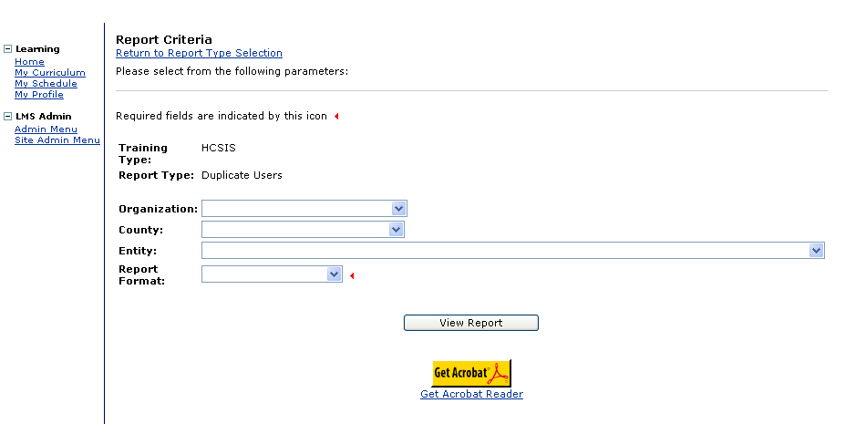
Parameter | Description | Mandatory or Optional
Organization | Select the organization from the drop-down options, if desired | Optional
County | Select the county from the drop-down menu options, if desired | Optional
Entity | Select the entity from the drop-down menu options, if desired | Optional
Report Format | Select how the report should appear from the list:  Rich text format and Adobe Acrobat (PDF) – display report results with graphics and a user-friendly layout. Plain text – displays report results without graphics and a standard layout | Mandatory

9. Email List by Course
This report provides the email addresses for all registered participants by course.

HCSIS roles that can access this report:
- Registrar
- Instructor
- Systems Administrator

HCSIS Reports, Continued

The search parameters are:
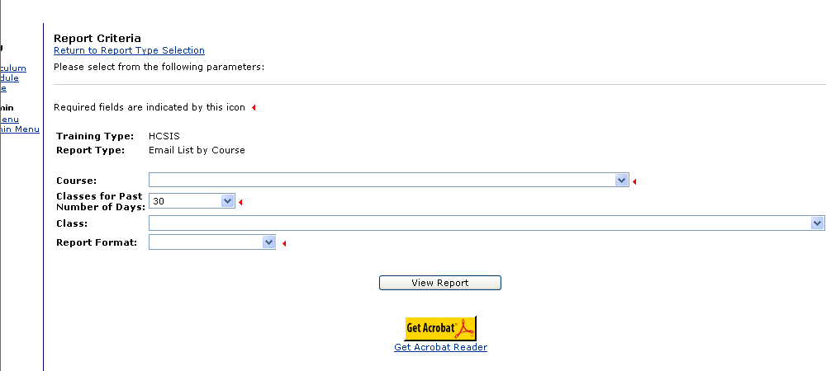
Parameter | Description | Mandatory or Optional
Course | Select the course from the drop-down menu options | Mandatory
Classes for Past Number of Days | Select the number of days for how far back you wish to search for a class offered on the LM S | Mandatory
Class | The system will display all classes offered for the time period selected in the first field. Select the name of the class from the drop-down list. | Optional
Report Format | Select how the report should appear from the list:  Rich text format and Adobe Acrobat (PDF) – display report results with graphics and a user-friendly layout. Plain text – displays report results without graphics and a standard layout | Mandatory

10. Email List by Training Role
This report provides the email addresses for all individuals assigned a particular training role.

HCSIS roles that can access this report:
- Registrar
- Instructor
- Systems Administrator

HCSIS Reports, Continued
The search parameters are:
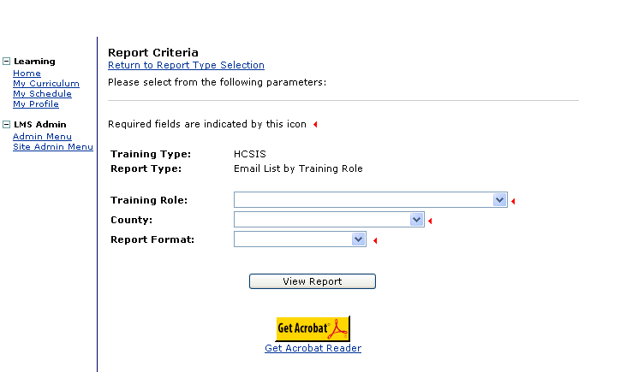
Parameter | Description | Mandatory or Optional
Training Role | Select the Training Role from the drop-down menu options | Mandatory
County | Select the appropriate county from the drop-down menu options | Mandatory
Report Format | Select how the report should appear from the list:  Rich text format and Adobe Acrobat (PDF) – display report results with graphics and a user-friendly layout. Plain text – displays report results without graphics and a standard layout | Mandatory

11. Enrollment Report
This report lists the names of all individuals within the selected county and/or entity and all the courses in which each individual is enrolled. The report also includes the date the individual attended the course, if applicable.

HCSIS roles that can access this report:
- Registrar
- Instructor
- Systems Administrator

HCSIS Reports, Continued
The search parameters are:

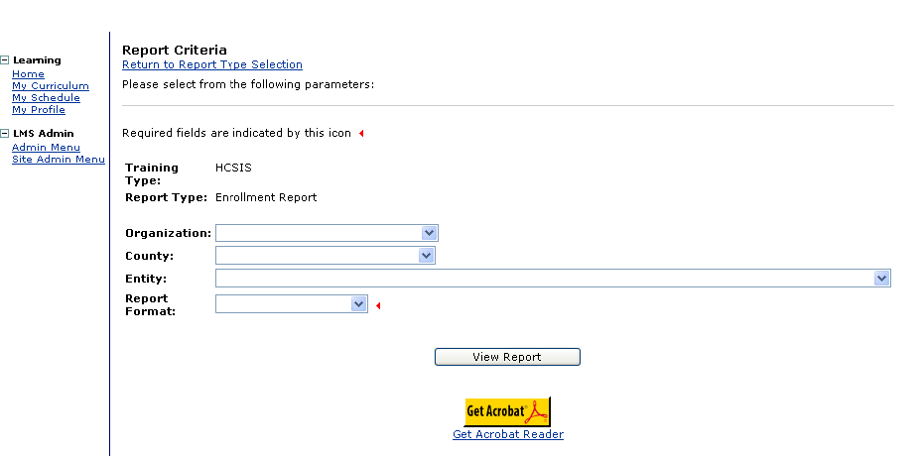
Parameter | Description | Mandatory or Optional
Organization | Select the Organization from the drop-down menu options | Optional
County | Select the appropriate county from the drop-down menu options | Optional
Entity | Select the Entity from the drop-down menu options, if desired | Optional
Report Format | Select how the report should appear from the list:  Rich text format and Adobe Acrobat (PDF) – display report results with graphics and a user-friendly layout. Plain text – displays report results without graphics and a standard layout | Mandatory

12. Evaluation Summary – Rate
This report displays a rating summary of the performance evaluation of an instructor and the course. It displays a summary of the numeric rank given by all participants for various criteria including, instructor, training delivery, content, relevance etc. for a selected course. Any comments entered by the participants are not included in this report.

HCSIS roles that can access this report:
- Registrar
- Instructor
- Systems Administrator
HCSIS Reports, Continued
The search parameters are:
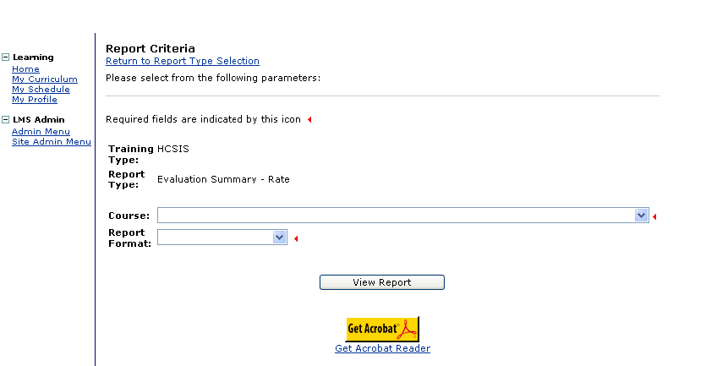
Parameter | Description | Mandatory or Optional
Course | Select the relevant course that is being evaluated from the drop-down menu options | Mandatory
Report Format | Select how the report should appear from the list:  Rich text format and Adobe Acrobat (PDF) – display report results with graphics and a user-friendly layout. Plain text – displays report results without graphics and a standard layout | Mandatory

13. Evaluation Summary – Text
This report displays a text summary of the performance evaluation of an instructor and the course. It displays all the comments entered by participants for various criteria including, instructor, training delivery, content, relevance etc. for a selected course.

HCSIS roles that can access this report:
- Registrar
- Instructor
- Systems Administrator

HCSIS Reports, Continued
The search parameters are:
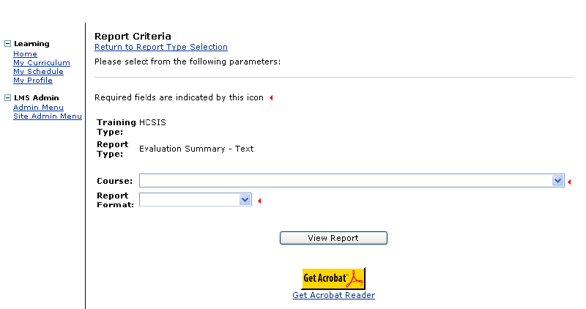
Parameter | Description | Mandatory or Optional
Course | Select the relevant course that is being evaluated from the drop-down menu options | Mandatory
Report Format | Select how the report should appear from the list:  Rich text format and Adobe Acrobat (PDF) – display report results with graphics and a user-friendly layout. Plain text – displays report results without graphics and a standard layout | Mandatory

14. Evaluation by Course – Rate
This report displays a rating summary of the performance evaluation of an instructor and the course by training location. It displays a summary of the numeric rank given by all participants at each training location for various criteria including, instructor, training delivery, content, relevance etc. for a selected course. Any comments entered by the participants are not included in this report.

HCSIS roles that can access this report:
- Registrar
- Instructor
- Systems Administrator

HCSIS Reports, Continued
The search parameters are:

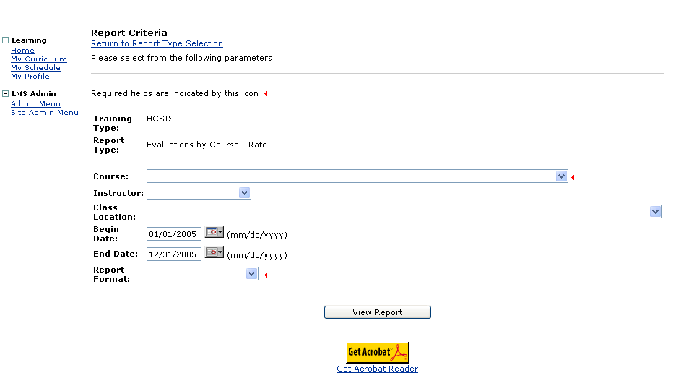

Parameter | Description | Mandatory or Optional
Course | Select the relevant course that is being evaluated from the drop-down menu options | Mandatory
Instructor | Select the name of the Instructor, if desired | Optional
Class Location | Select the specific class location, if desired | Optional
Begin and End Dates | Selecting a begin and end date narrows the search results, if desired | Optional
Report Format | Select how the report should appear from the list:  Rich text format and Adobe Acrobat (PDF) – display report results with graphics and a user-friendly layout. Plain text – displays report results without graphics and a standard layout | Mandatory

15. Evaluation by Course – Text
This report displays a text summary of the performance evaluation of an instructor and the course by training location. It displays all the comments entered by participants at each location for various criteria including, instructor, training delivery, content, relevance etc. for a selected course.

HCSIS Reports, Continued
HCSIS roles that can access this report:
- Registrar
- Instructor
- Systems Administrator

The search parameters are:
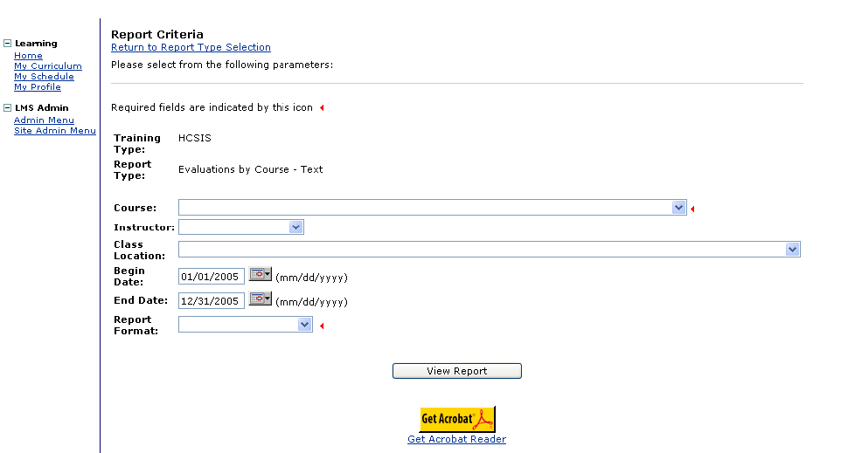
Parameter | Description | Mandatory or Optional
Course | Select the relevant course that is being evaluated from the drop-down menu options | Mandatory
Instructor | Select the name of the Instructor, if desired | Optional
Class Location | Select the specific class location, if desired | Optional
Begin and End Dates | Selecting a begin and end date narrows the search results, if desired | Optional
Report Format | Select how the report should appear from the list:  Rich text format and Adobe Acrobat (PDF) – display report results with graphics and a user-friendly layout. Plain text – displays report results without graphics and a standard layout | Mandatory

16. Evaluation by Instructor – Rate
This report displays a rating summary of the performance evaluation of an instructor. It displays a summary of the numeric rank given by all participants for various criteria including instructor, training
HCSIS Reports, Continued
delivery, content, relevance etc. for a selected course. Any comments entered by the participants are not included in this report.

HCSIS roles that can access this report:
- Registrar
- Instructor
- Systems Administrator

The search parameters are:
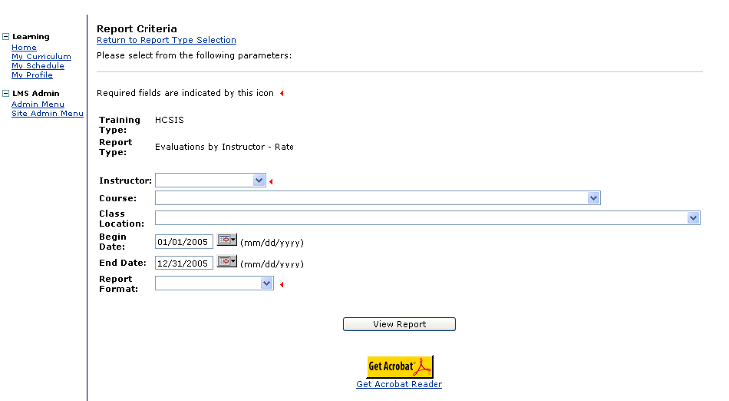
Parameter | Description | Mandatory or Optional
Instructor | Select the name of the Instructor, if desired | Mandatory
Course | Select the relevant course that is being evaluated from the drop-down menu options | Optional
Class Location | Select the specific class location, if desired | Optional
Begin and End Dates | Selecting a begin and end date narrows the search results, if desired | Optional
Report Format | Select how the report should appear from the list:  Rich text format and Adobe Acrobat (PDF) – display report results with graphics and a user-friendly layout. Plain text – displays report results without graphics and a standard layout | Mandatory

HCSIS Reports, Continued

17. Evaluation by Instructor – Text
This report displays a text summary of the performance evaluation of an instructor. It displays all the comments entered by participants for various criteria including, instructor, training delivery, content, relevance etc. for a selected course.

HCSIS roles that can access this report:
- Registrar
- Instructor
- Systems Administrator

The search parameters are:
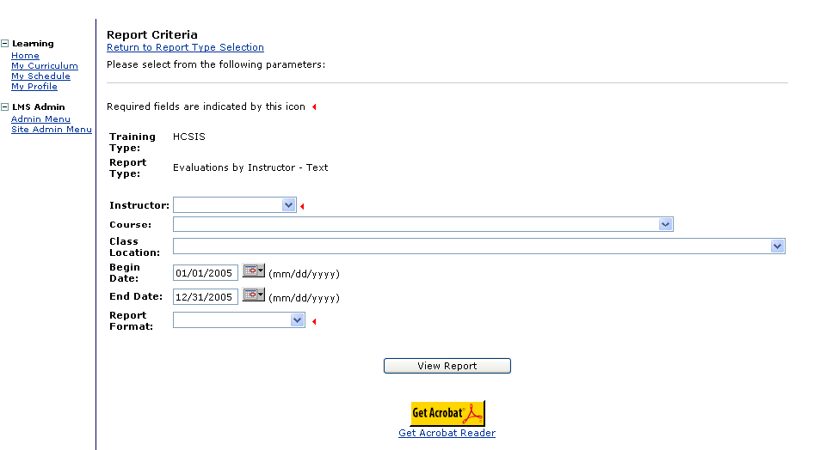
Parameter | Description | Mandatory or Optional
Instructor | Select the name of the Instructor, if desired | Mandatory
Course | Select the relevant course that is being evaluated from the drop-down menu options | Optional
Class Location | Select the specific class location, if desired | Optional
Begin and End Dates | Selecting a begin and end date narrows the search results, if desired | Optional
Report Format | Select how the report should appear from the list:  Rich text format and Adobe Acrobat (PDF) – display report results with graphics and a user-friendly layout. Plain text – displays report results without graphics and a standard layout | Mandatory
HCSIS Reports, Continued

18. Registration for Allocated Classes
This report displays a summary count of all participants registered for a particular course by entity.

HCSIS roles that can access this report:
- Registrar
- Instructor
- Systems Administrator

The search parameters are:
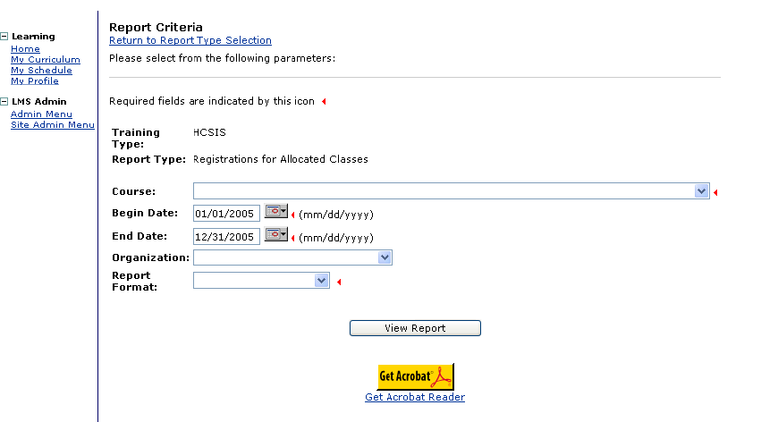
Parameter | Description | Mandatory or Optional
Course | Select the relevant course that is being evaluated from the drop-down menu options | Mandatory
Begin and End Dates | Selecting a begin and end date narrows the search results, if desired | Optional
Organization | Select the organization from the drop-down menu options, if desired | Optional
Report Format | Select how the report should appear from the list:  Rich text format and Adobe Acrobat (PDF) – display report results with graphics and a user-friendly layout. Plain text – displays report results without graphics and a standard layout | Mandatory

HCSIS Reports, Continued

19. Scheduling Report
This report displays a summary of all training courses and the instructor for each scheduled class, starting with the most recent, over the course of the time period selected.

HCSIS roles that can access this report:
- Logistics Manager
- Registrar
- Instructor
- Systems Administrator

The search parameters are:
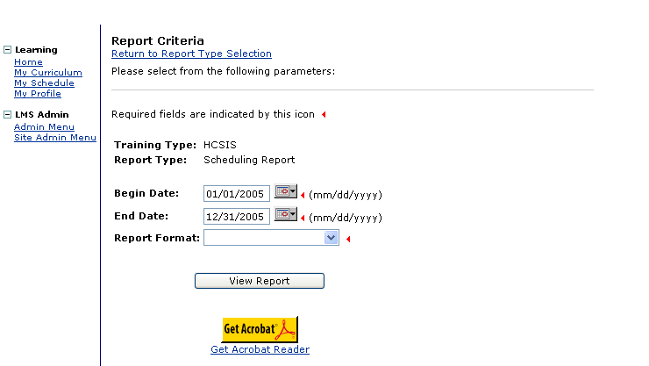
Parameter | Description | Mandatory or Optional
Begin and End Dates | Select a begin and end date to narrow the search results | Mandatory
Report Format | Select how the report should appear from the list:  Rich text format and Adobe Acrobat (PDF) – display report results with graphics and a user-friendly layout. Plain text – displays report results without graphics and a standard layout | Mandatory

20. Transcripts - Personal
This report displays a transcript for an individual for all training courses completed by an individual. The reports displays the name of the course, the course type, number of training hours, start date and date completed, if applicable.

HCSIS roles that can access this report:
- Registrar
- Instructor
- Systems Administrator

The search parameters are:
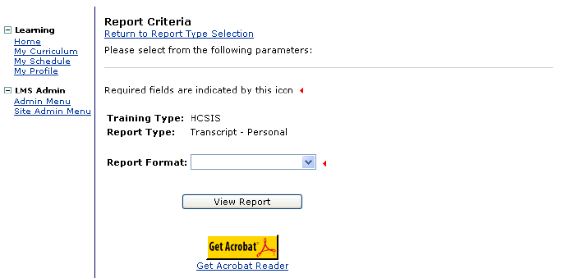
Parameter | Description | Mandatory or Optional
Report Format | Select how the report should appear from the list:  Rich text format and Adobe Acrobat (PDF) – display report results with graphics and a user-friendly layout. Plain text – displays report results without graphics and a standard layout | Mandatory

21. Transcripts for Entity Personnel
This report displays a transcript for individuals by entity for all training courses completed by the individual. The reports displays the name of the course, the course type, number of training hours, start date and date completed, if applicable, for each individual.

HCSIS Reports, Continued
HCSIS roles that can access this report:
- Registrar
- Instructor
- Systems Administrator

The search parameters are:

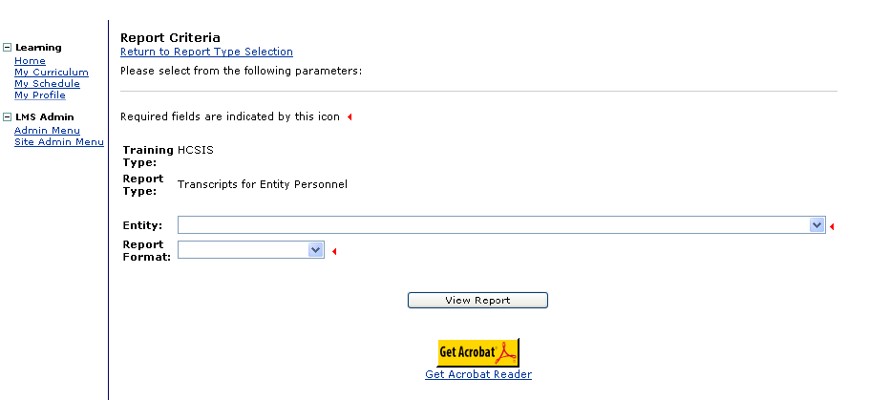

Parameter | Description | Mandatory or Optional
Entity | Select an entity from the drop-down results | Mandatory
Report Format | Select how the report should appear from the list:  Rich text format and Adobe Acrobat (PDF) – display report results with graphics and a user-friendly layout. Plain text – displays report results without graphics and a standard layout | Mandatory

22. User and Roles Report
This report displays the various roles assigned to users by organization, county and entity.

HCSIS roles that can access this report:
- Registrar
- Instructor
- Systems Administrator

HCSIS Reports, Continued
The search parameters are:

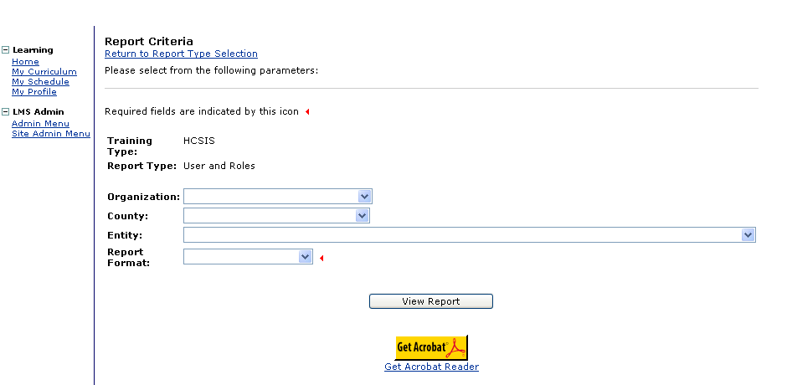
Parameter | Description | Mandatory or Optional
Organization | Select the organization from the drop-down menu options, if desired | Optional
County | Select a county from the drop-down results, if desired | Optional
Entity | Select the relevant from the drop-down menu options, if desired | Optional
Report Format | Select how the report should appear from the list:  Rich text format and Adobe Acrobat (PDF) – display report results with graphics and a user-friendly layout. Plain text – displays report results without graphics and a standard layout | Mandatory

Investigations Program Reports
The following reports list information for Certified Investigators and/ or applicants enrolled in a Certified Investigator course or a re-certification course.

1. Certification Management
This report displays information about individuals including certification date and certification expiration date.
HCSIS roles that can access this report:
- Logistics Manager
- Registrar
- Instructor
- Systems Administrator

The search parameters are:

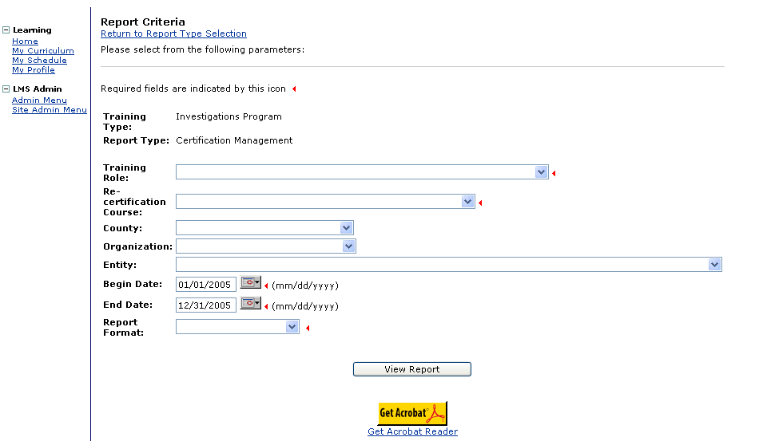
Investigations Program Reports, Continued
Parameter | Description | Mandatory or Optional
Training Role | Select the role from the drop-down menu options | Mandatory
Re-certification Course | Select a course from the drop-down menu options | Mandatory
County | Select a county from the drop-down results, if desired | Optional
Organization | Select the organization from the drop-down menu options | Optional
Entity | Select the relevant from the drop-down menu options | Optional
Begin and End Dates | Selecting a begin and end date narrows the search results | Mandatory
Report Format | Select how the report should appear from the list:  Rich text format and Adobe Acrobat (PDF) – display report results with graphics and a user-friendly layout. Plain text – displays report results without graphics and a standard layout | Mandatory

2. Certification Investigation (CI) All Users
This report displays the list of all CI applicants and Certified Investigators.

HCSIS roles that can access this report:
- Logistics Manager
- Registrar
- Instructor
- Systems Administrator

Investigations Program Reports, Continued
The search parameters are:
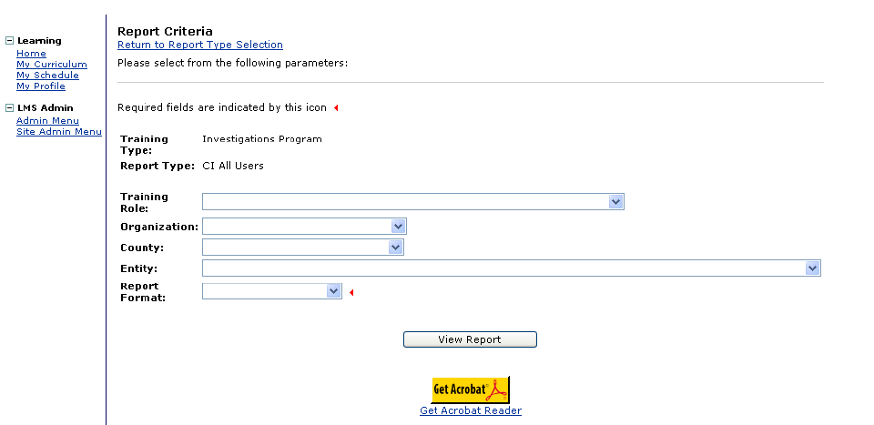
Parameter | Description | Mandatory or Optional
Training Role | Select the role from the drop-down menu options | Optional
Organization | Select the organization from the drop-down menu options, if desired | Optional
County | Select a county from the drop-down results, if desired | Optional
Entity | Select the relevant from the drop-down menu options, if desired | Optional
Report Format | Select how the report should appear from the list:  Rich text format and Adobe Acrobat (PDF) – display report results with graphics and a user-friendly layout. Plain text – displays report results without graphics and a standard layout | Mandatory

3. CI Applicants Who Failed Report
This report displays the list of all CI applicants who did not pass the CI exams, the location of the exam, the number of exam attempts, and exam dates.

HCSIS roles that can access this report:
- Logistics Manager
- Registrar
- Instructor
- Systems Administrator

Investigations Program Reports, Continued
The search parameters are:

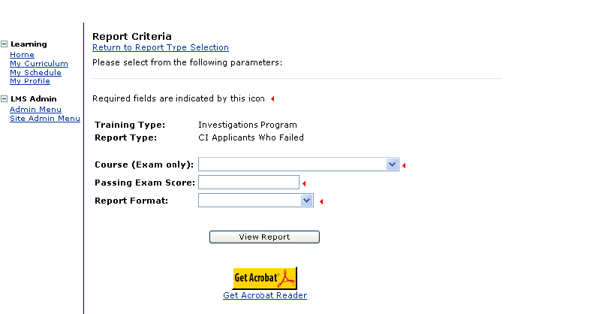

Parameter | Description | Mandatory or Optional
Course (Exam only) | Select the course from the drop-down menu options | Mandatory
Passing Exam Score | Enter the applicants score in this field | Mandatory
Report Format | Select how the report should appear from the list:  Rich text format and Adobe Acrobat (PDF) – display report results with graphics and a user-friendly layout. Plain text – displays report results without graphics and a standard layout | Mandatory

4. CI Attempt Statistics
This report displays the statistical date regarding attempts, average score, high/low spread, number of participants who took passed or failed, the percentage who passed and the number of exams administered.

HCSIS roles that can access this report:
- Logistics Manager
- Registrar
- Instructor
- Systems Administrator

Investigations Program Reports, Continued
The search parameters are:

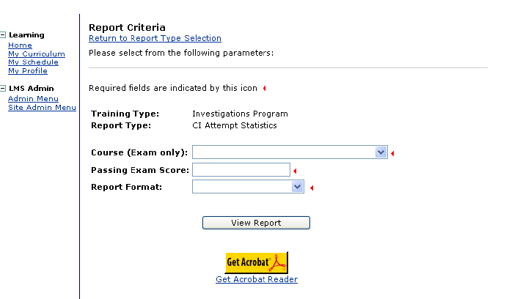

Parameter | Description | Mandatory or Optional
Course (Exam only) | Select the course from the drop-down menu options | Mandatory
Passing Exam Score | Enter the applicants score in this field | Mandatory
Report Format | Select how the report should appear from the list:  Rich text format and Adobe Acrobat (PDF) – display report results with graphics and a user-friendly layout. Plain text – displays report results without graphics and a standard layout | Mandatory

5. CI Attendance Reports
This report displays the attendance for the selected course.

HCSIS roles that can access this report:
- Logistics Manager
- Registrar
- Instructor
- Systems Administrator

Investigations Program Reports, Continued
The search parameters are:

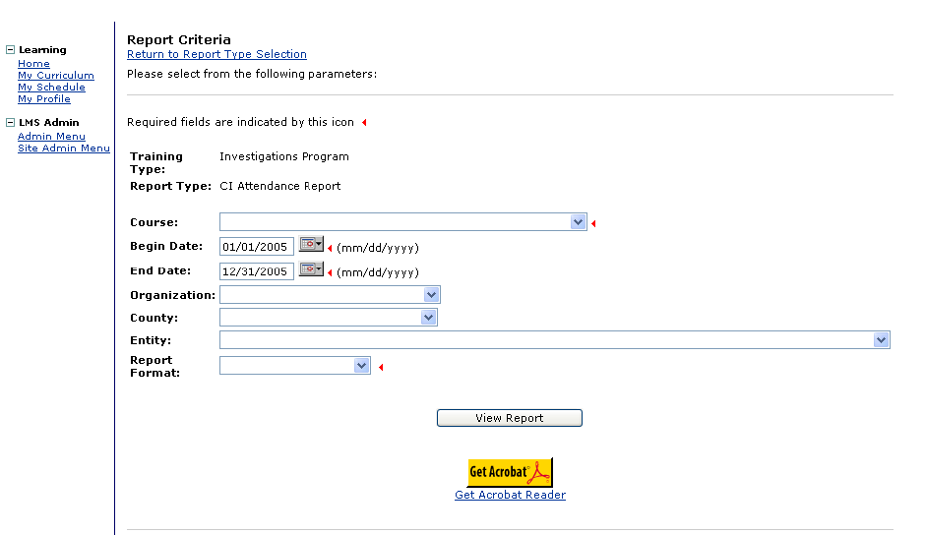

Parameter | Description | Mandatory or Optional
Course | Select the course from the drop-down menu options | Mandatory
Begin and End Dates | Selecting a begin and end date narrows the search results, if desired | Mandatory
Organization | Select the organization from the drop-down menu options, if desired | Optional
County | Select a county from the drop-down results, if desired | Optional
Entity | Select the relevant from the drop-down menu options, if desired | Optional
Report Format | Select how the report should appear from the list:  Rich text format and Adobe Acrobat (PDF) – display report results with graphics and a user-friendly layout. Plain text – displays report results without graphics and a standard layout | Mandatory

6. CI Course and Roles
This report provides a list of all courses offered on the LMS and the roles for which the course is available.

Investigations Program Reports, Continued
HCSIS roles that can access this report:
- Logistics Manager
- Registrar
- Instructor
- Systems Administrator

The search parameters are:

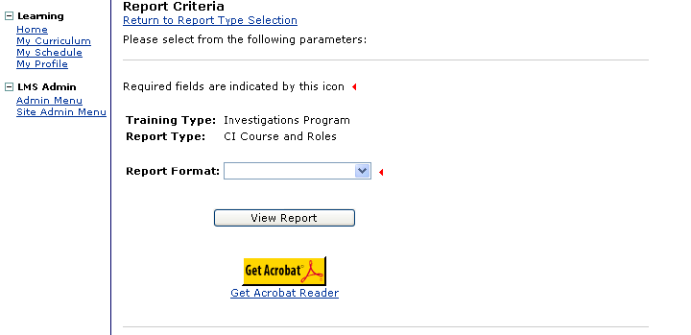

Parameter | Description | Mandatory or Optional
Report Format | Select how the report should appear from the list:  Rich text format and Adobe Acrobat (PDF) – display report results with graphics and a user-friendly layout. Plain text – displays report results without graphics and a standard layout | Mandatory

7. CI Course Requirements
This report displays the individuals registered for a course, all previous courses completed by the individual and the completion dates.

Investigations Program Reports, Continued
HCSIS roles that can access this report:
- Logistics Manager
- Registrar
- Instructor
- Systems Administrator

The search parameters are:

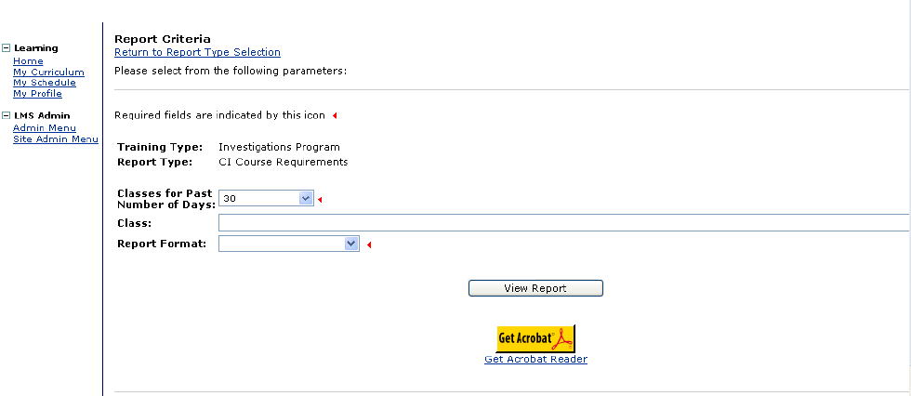

Parameter | Description | Mandatory or Optional
Classes for Past Number of Days | Select the number of past days from the drop-down menu options | Mandatory
Class | Select the class from the drop-down menu options | Mandatory
Report Format | Select how the report should appear from the list:  Rich text format and Adobe Acrobat (PDF) – display report results with graphics and a user-friendly layout. Plain text – displays report results without graphics and a standard layout | Mandatory

8. CI Enrollment Report
This report displays the list of individuals, enrollment in CI courses and date completed.

HCSIS roles that can access this report:
- Logistics Manager
- Registrar
- Instructor
- Systems Administrator
Investigations Program Reports, Continued
The search parameters are:

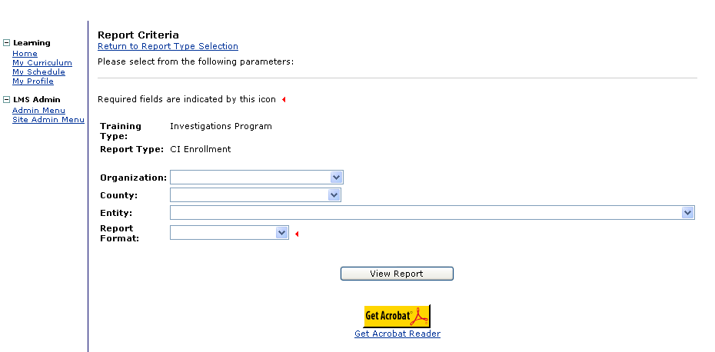

Parameter | Description | Mandatory or Optional
Organization | Select the organization from the drop-down menu options, if desired | Optional
County | Select a county from the drop-down results, if desired | Optional
Entity | Select the relevant from the drop-down menu options, if desired | Optional
Report Format | Select how the report should appear from the list:  Rich text format and Adobe Acrobat (PDF) – display report results with graphics and a user-friendly layout. Plain text – displays report results without graphics and a standard layout | Mandatory

9. CI Roster (Course) Report
This report displays a class roster including the list of individuals enrolled for a particular CI course.

HCSIS roles that can access this report:
- Logistics Manager
- Registrar
- Instructor
- Systems Administrator

Investigations Program Reports, Continued

The search parameters are:

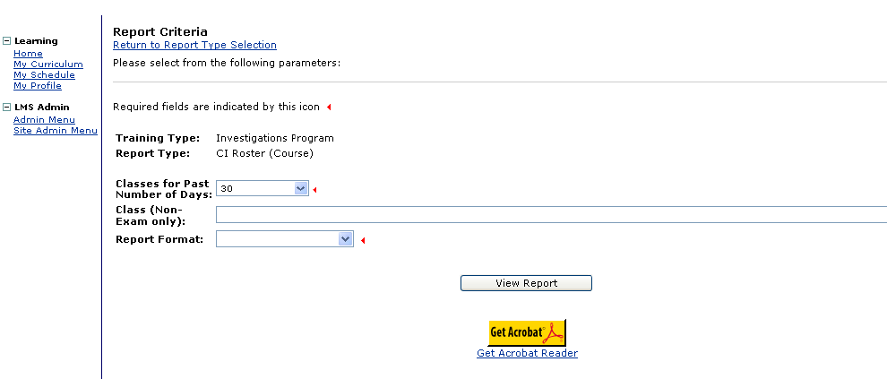

Parameter | Description | Mandatory or Optional
Classes for Past Number of Days | Select the number of past days from the drop-down menu options | Mandatory
Class (Non-Exam only) | Select the class from the drop-down menu options | Mandatory
Report Format | Select how the report should appear from the list:  Rich text format and Adobe Acrobat (PDF) – display report results with graphics and a user-friendly layout. Plain text – displays report results without graphics and a standard layout | Mandatory

10. CI Roster (Exam) Report
This report displays a class roster including the list of individuals, email and number of attempts each individual has made for a particular CI exam.

HCSIS roles that can access this report:
- Logistics Manager
- Registrar
- Instructor
- Systems Administrator

Investigations Program Reports, Continued

The search parameters are:

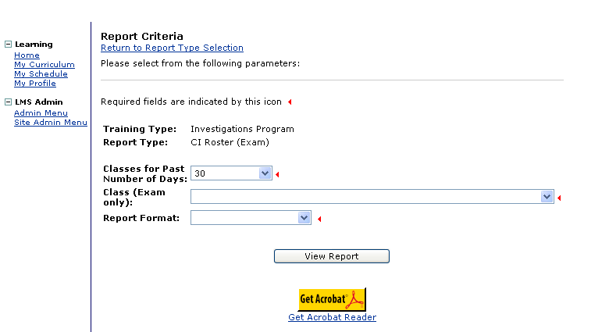

Parameter | Description | Mandatory or Optional
Classes for Past Number of Days | Select the number of past days from the drop-down menu options | Mandatory
Class (Exam only) | Select the class from the drop-down menu options | Mandatory
Report Format | Select how the report should appear from the list:  Rich text format and Adobe Acrobat (PDF) – display report results with graphics and a user-friendly layout. Plain text – displays report results without graphics and a standard layout | Mandatory

11. CI Scheduling
This report displays the list of CI courses scheduled, location, enrollment and Instructor information.

HCSIS roles that can access this report:
- Logistics Manager
- Registrar
- Instructor
- Systems Administrator

Investigations Program Reports, Continued

The search parameters are:

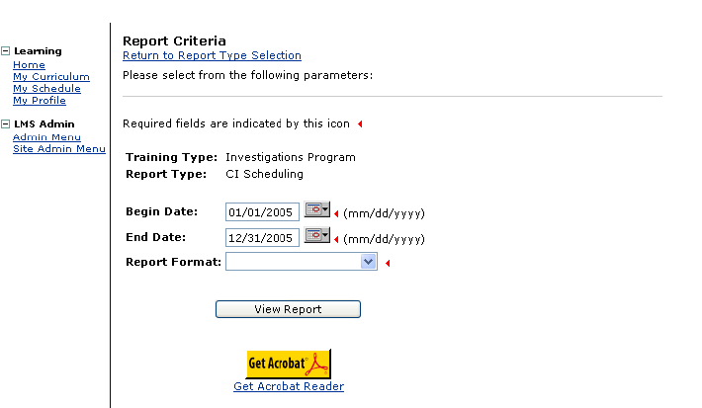

Parameter | Description | Mandatory or Optional
Begin and End Dates | Selecting a begin and end date narrows the search results, if desired | Mandatory
Report Format | Select how the report should appear from the list:  Rich text format and Adobe Acrobat (PDF) – display report results with graphics and a user-friendly layout. Plain text – displays report results without graphics and a standard layout | Mandatory

12. CI Session Statistics
This report displays the statistics by location including average score, passed and failed attempts, attendance and enrollment details.

HCSIS roles that can access this report:
- Logistics Manager
- Registrar
- Instructor
- Systems Administrator

Investigations Program Reports, Continued

The search parameters are:

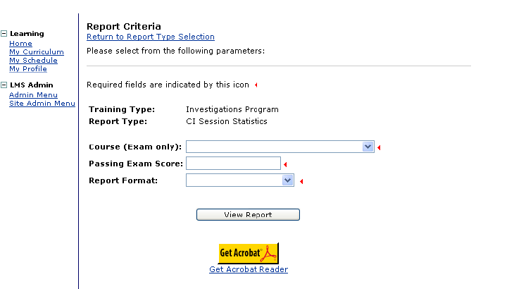

Parameter | Description | Mandatory or Optional
Course (Exam only) | Select the course from the drop-down menu options | Mandatory
Passing Exam Score | Enter the applicants score in this field | Mandatory
Report Format | Select how the report should appear from the list:  Rich text format and Adobe Acrobat (PDF) – display report results with graphics and a user-friendly layout. Plain text – displays report results without graphics and a standard layout | Mandatory

Quality Management Reports

1. Attendance Report
This report provides information about the individuals who have registered for a particular course offered on the LMS.

HCSIS roles that can access the Attendance Reports:
- Registrar
- Instructor
- Systems Administrator

The search parameters are:

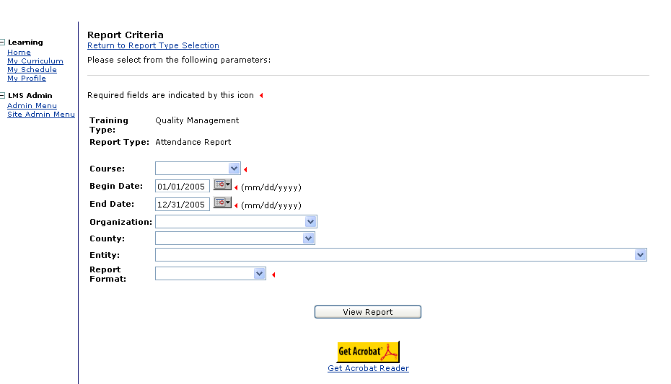

Parameter | Description | Mandatory or Optional
Course | Select from the drop-down list to limit the results to display attendance only for the course selected | Mandatory
Begin & End Dates | Enter a date span to limit the results to a period | Optional
Organization | Select from the drop-down list, if desired | Optional
County | Select the county from the drop-down list, if desired. | Optional
Entity | Select the entity from the drop-down list, if desired | Optional
Report Format | Select how the report should appear from the list:  Rich text format and Adobe Acrobat (PDF) – display report results with graphics and a user-friendly layout. Plain text – displays report results without graphics and a standard layout | Mandatory
Quality Management Reports, Continued

2. Class Roster
This report provides a list of all registered participant names, their login ID and County for a particular course offered on the LMS.

HCSIS roles that can access this report:
- Registrar
- Instructor
- Systems Administrator

The search parameters are:

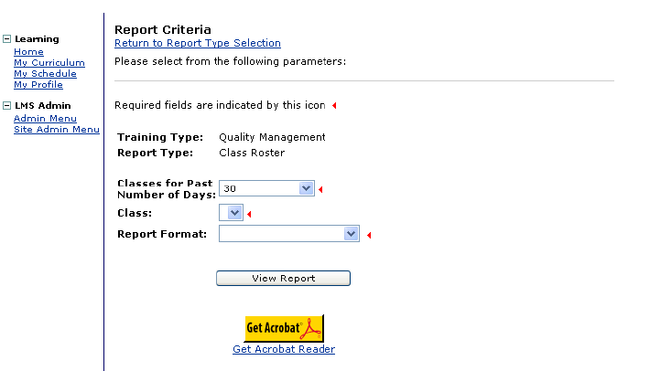

Parameter | Description | Mandatory or Optional
Classes for Past Number of Days | Select the number of days for how far back you wish to search for a class offered on the LM S | Mandatory
Class | The system will display all classes offered for the time period selected in the first field. Select the name of the class from the drop-down list. | Mandatory
Report Format | Select how the report should appear from the list:  Rich text format and Adobe Acrobat (PDF) – display report results with graphics and a user-friendly layout. Plain text – displays report results without graphics and a standard layout | Mandatory

Quality Management Reports, Continued

3. Class Roster – Additional Information
This report displays the names of all participants enrolled in a selected course. Additionally, it displays the course, location, dates, instructor, assistant instructor and capacity information at the top of the page.

HCSIS roles that can access this report:
- Registrar
- Instructor
- Systems Administrator

The search parameters are:

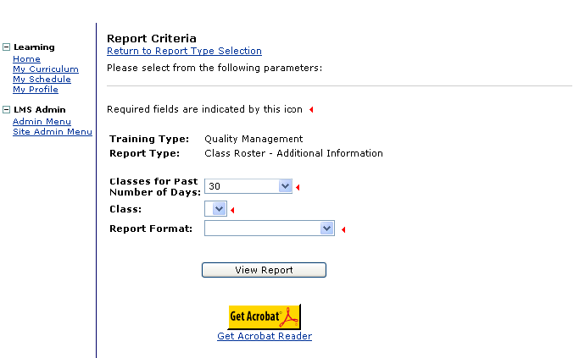
Quality Management Reports, Continued

Parameter | Description | Mandatory or Optional
Classes for Past Number of Days | Select the number of days for how far back you wish to search for a class offered on the LM S | Mandatory
Class | The system will display all classes offered for the time period selected in the first field. Select the name of the class from the drop-down list. | Mandatory
Report Format | Select how the report should appear from the list:  Rich text format and Adobe Acrobat (PDF) – display report results with graphics and a user-friendly layout. Plain text – displays report results without graphics and a standard layout | Mandatory

4. Course and Roles
This report provides a list of all courses offered on the LMS and the roles for which the course is available.

HCSIS roles that can access this report:
- Logistics Manager
- Registrar
- Instructor
- Systems Administrator

The search parameters are:

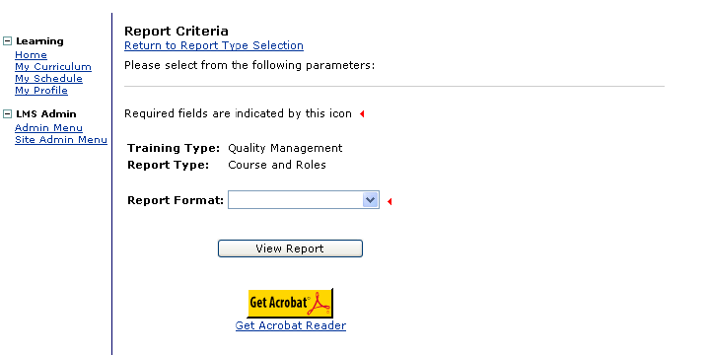
Quality Management Reports, Continued
Parameter | Description | Mandatory or Optional
Report Format | Select how the report should appear from the list:  Rich text format and Adobe Acrobat (PDF) – display report results with graphics and a user-friendly layout. Plain text – displays report results without graphics and a standard layout | Mandatory

5. Email List by Course
This report provides the email addresses for all registered participants by course.

HCSIS roles that can access this report:
- Registrar
- Instructor
- Systems Administrator

The search parameters are:

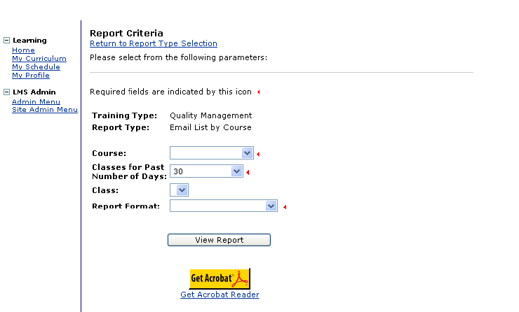
Quality Management Reports, Continued
Parameter | Description | Mandatory or Optional
Course | Select the course from the drop-down menu options | Mandatory
Classes for Past Number of Days | Select the number of days for how far back you wish to search for a class offered on the LM S | Mandatory
Class | The system will display all classes offered for the time period selected in the first field. Select the name of the class from the drop-down list. | Optional
Report Format | Select how the report should appear from the list:  Rich text format and Adobe Acrobat (PDF) – display report results with graphics and a user-friendly layout. Plain text – displays report results without graphics and a standard layout | Mandatory

6. Email List by Training Role
This report provides the email addresses for all individuals assigned a particular training role.

HCSIS roles that can access this report:
- Registrar
- Instructor
- Systems Administrator

The search parameters are:

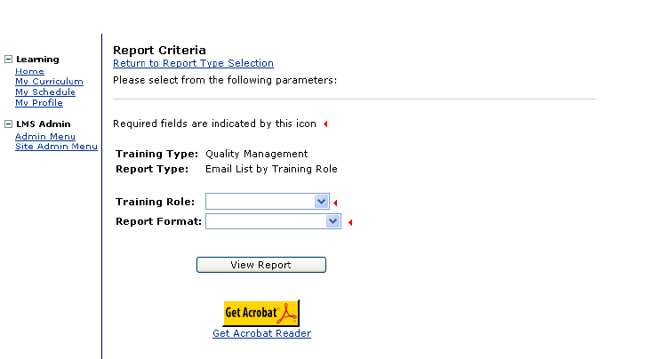
Quality Management Reports, Continued
Parameter | Description | Mandatory or Optional
Training Role | Select the Training Role from the drop-down menu options | Mandatory
County | Select the appropriate county from the drop-down menu options | Mandatory
Report Format | Select how the report should appear from the list:  Rich text format and Adobe Acrobat (PDF) – display report results with graphics and a user-friendly layout. Plain text – displays report results without graphics and a standard layout | Mandatory

7. Enrollment Report
This report lists the names of all individuals within the selected county and/or entity and all the courses completed by these individuals.

HCSIS roles that can access this report:
- Registrar
- Instructor
- Systems Administrator

The search parameters are:

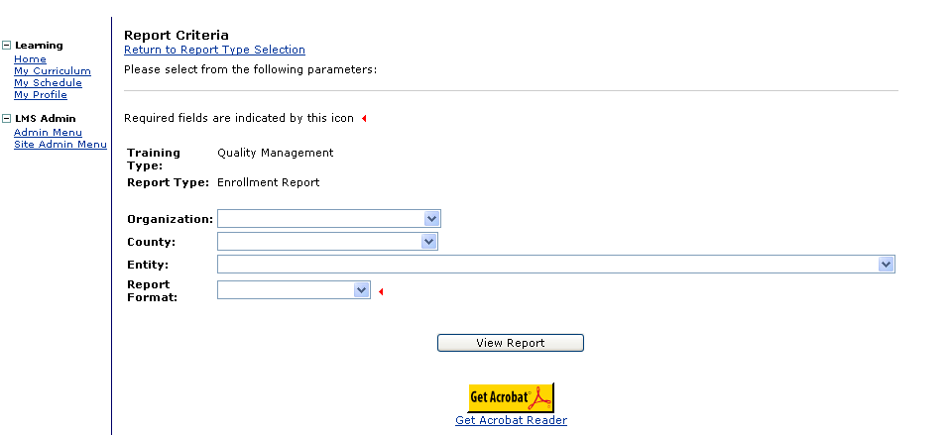
Quality Management Reports, Continued
Parameter | Description | Mandatory or Optional
Organization | Select the Organization from the drop-down menu options | Optional
County | Select the appropriate county from the drop-down menu options | Optional
Entity | Select the Entity from the drop-down menu options, if desired | Optional
Report Format | Select how the report should appear from the list:  Rich text format and Adobe Acrobat (PDF) – display report results with graphics and a user-friendly layout. Plain text – displays report results without graphics and a standard layout | Mandatory

8. Scheduling Report
This report displays a summary of all training courses and the instructor leading each class that has been scheduled, starting with the most recent, over the course of the time-period selected.

HCSIS roles that can access this report:
- Logistics Manager
- Registrar
- Instructor
- Systems Administrator

Quality Management Reports, Continued

The search parameters are:

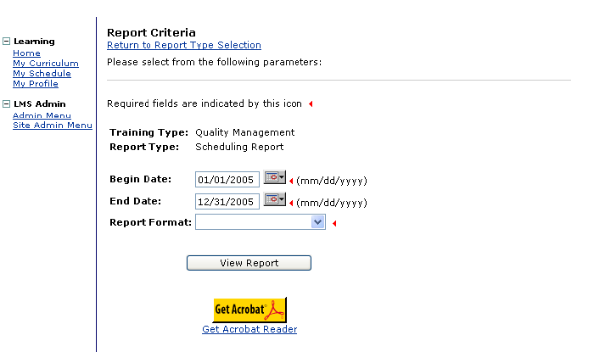

Parameter | Description | Mandatory or Optional
Begin and End Dates | Select a begin and end date to narrow the search results | Mandatory
Report Format | Select how the report should appear from the list:  Rich text format and Adobe Acrobat (PDF) – display report results with graphics and a user-friendly layout. Plain text – displays report results without graphics and a standard layout | Mandatory

9. User and Roles Report
This report displays the various roles assigned to users by organization, county and entity.

HCSIS roles that can access this report:
- Registrar
- Instructor
- Systems Administrator

Quality Management Reports, Continued

The search parameters are:

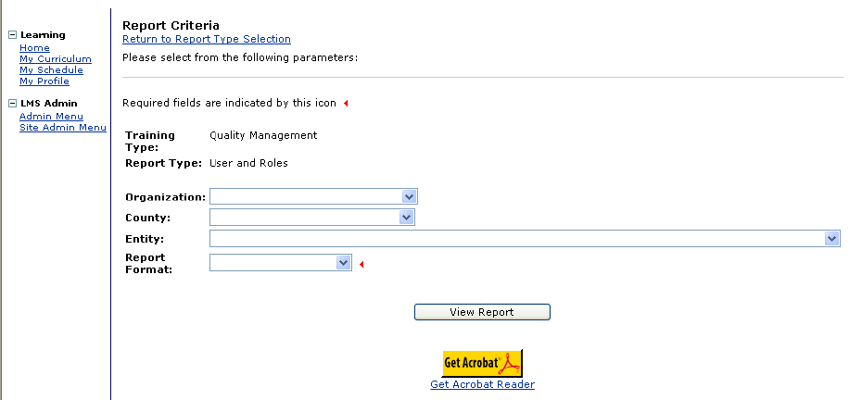

Parameter | Description | Mandatory or Optional
Organization | Select the organization from the drop-down menu options, if desired | Optional
County | Select a county from the drop-down results, if desired | Optional
Entity | Select the relevant from the drop-down menu options, if desired | Optional
Report Format | Select how the report should appear from the list:  Rich text format and Adobe Acrobat (PDF) – display report results with graphics and a user-friendly layout. Plain text – displays report results without graphics and a standard layout | Mandatory

Supports Coordination Reports

1. Attendance Report
This report provides information about the individuals who have registered for a particular course offered on the LMS.

HCSIS roles that can access this report:
- Registrar
- Instructor
- Systems Administrator

The search parameters are:

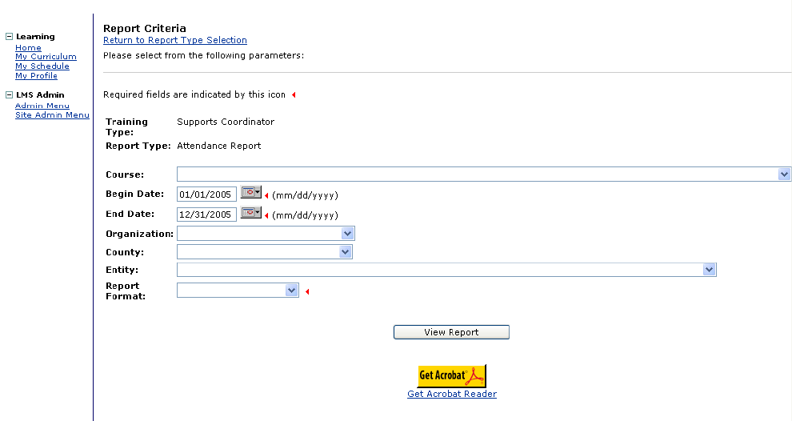
Supports Coordination Reports, Continued
Parameter | Description | Mandatory or Optional
Course | Select the relevant course that is being evaluated from the drop-down menu options | Optional
Begin and End Dates | Selecting a begin and end date narrows the search results | Mandatory
Organization | Select the organization from the drop-down options, if desired | Optional
County | Select the county from the drop-down menu options, if desired | Optional
Entity | Select the entity from the drop-down menu options, if desired | Optional
Report Format | Select how the report should appear from the list:  Rich text format and Adobe Acrobat (PDF) – display report results with graphics and a user-friendly layout. Plain text – displays report results without graphics and a standard layout | Mandatory

2. Class Roster
This report provides a list of all registered participant names, their login ID and County for a particular course offered on the LMS.

HCSIS roles that can access this report:
- Registrar
- Instructor
- Systems Administrator

Supports Coordination Reports, Continued
The search parameters are:

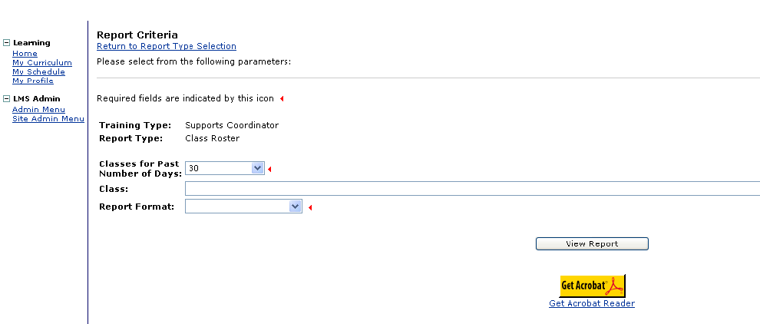

Parameter | Description | Mandatory or Optional
Classes for Past Number of Days | Select the number of days for how far back you wish to search for a class offered on the LM S | Mandatory
Class | The system will display all classes offered for the time period selected in the first field. Select the name of the class from the drop-down list. | Mandatory
Report Format | Select how the report should appear from the list:  Rich text format and Adobe Acrobat (PDF) – display report results with graphics and a user-friendly layout. Plain text – displays report results without graphics and a standard layout | Mandatory

3. Class Roster – Additional Information
This report displays the names of all participants enrolled in a selected course. Additionally, it displays the course, location, dates, instructor, assistant instructor and capacity information at the top of the page.

HCSIS roles that can access this report:
- Registrar
- Instructor
- Systems Administrator

Supports Coordination Reports, Continued
The search parameters are:

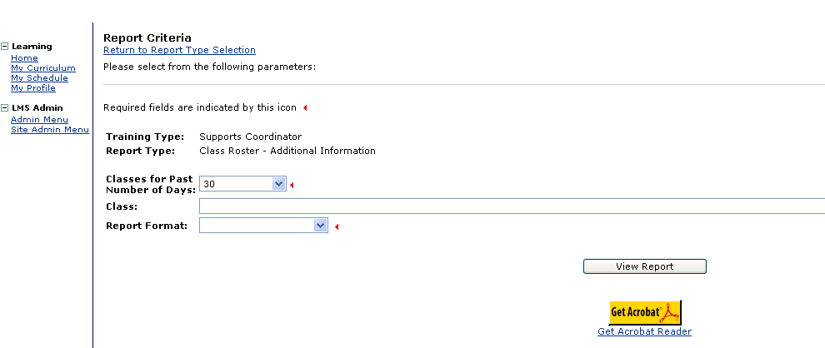

Parameter | Description | Mandatory or Optional
Classes for Past Number of Days | Select the number of days for how far back you wish to search for a class offered on the LM S | Mandatory
Class | The system will display all classes offered for the time period selected in the first field. Select the name of the class from the drop-down list. | Mandatory
Report Format | Select how the report should appear from the list:  Rich text format and Adobe Acrobat (PDF) – display report results with graphics and a user-friendly layout. Plain text – displays report results without graphics and a standard layout | Mandatory

4. Course and Roles
This report provides a list of all courses offered on the LMS and the roles for whom the course is available.

HCSIS roles that can access this report:
- Logistics Manager
- Registrar
- Instructor
- Systems Administrator

Supports Coordination Reports, Continued
The search parameters are:

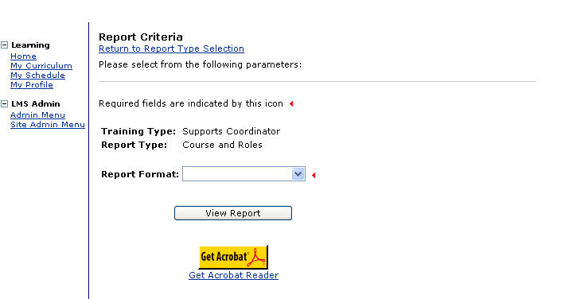

Parameter | Description | Mandatory or Optional
Report Format | Select how the report should appear from the list:  Rich text format and Adobe Acrobat (PDF) – display report results with graphics and a user-friendly layout. Plain text – displays report results without graphics and a standard layout | Mandatory

5. Email List by Course
This report provides the email addresses for all registered participants by course.

HCSIS roles that can access this report:
- Registrar
- Instructor
- Systems Administrator

Supports Coordination Reports, Continued
The search parameters are:

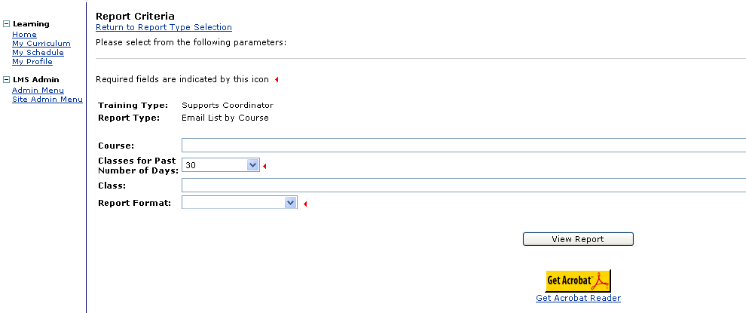

Parameter | Description | Mandatory or Optional
Course | Select the relevant course that is being evaluated from the drop-down menu options | Mandatory
Classes for Past Number of Days | Select the number of days for how far back you wish to search for a class offered on the LM S | Mandatory
Class | The system will display all classes offered for the time period selected in the first field. Select the name of the class from the drop-down list. | Optional
Report Format | Select how the report should appear from the list:  Rich text format and Adobe Acrobat (PDF) – display report results with graphics and a user-friendly layout. Plain text – displays report results without graphics and a standard layout | Mandatory

6. Email List by Training Role
This report provides the email addresses for all individuals assigned a particular training role.

HCSIS roles that can access this report:
- Registrar
- Instructor
- Systems Administrator

Supports Coordination Reports, Continued
The search parameters are:

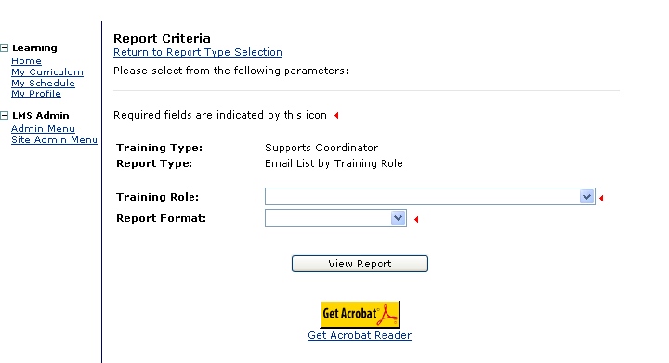

Parameter | Description | Mandatory or Optional
Training Role | Select the relevant training role from the drop-down menu options | Mandatory
Report Format | Select how the report should appear from the list:  Rich text format and Adobe Acrobat (PDF) – display report results with graphics and a user-friendly layout. Plain text – displays report results without graphics and a standard layout | Mandatory

7. Enrollment Report
This report lists the names of all individuals within the selected county and/or entity and all the courses in which each individual is enrolled. The report also includes the date the individual attended the course, if applicable.

HCSIS roles that can access this report:
- Registrar
- Instructor
- Systems Administrator

Supports Coordination Reports, Continued
The search parameters are:

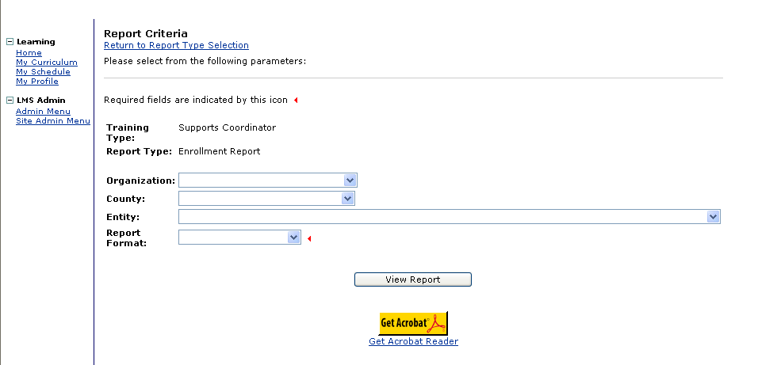

Parameter | Description | Mandatory or Optional
Organization | Select the organization from the drop-down options, if desired | Optional
County | Select the county from the drop-down menu options, if desired | Optional
Entity | Select the entity from the drop-down menu options, if desired | Optional
Report Format | Select how the report should appear from the list:  Rich text format and Adobe Acrobat (PDF) – display report results with graphics and a user-friendly layout. Plain text – displays report results without graphics and a standard layout | Mandatory

8. Scheduling Report
This report displays the location, enrolled number of participants vis-à-vis capacity, start and end dates, instructor and assistant instructor per course.

HCSIS roles that can access this report:
- Logistics Manager
- Registrar
- Instructor
- Systems Administrator

Supports Coordination Reports, Continued
The search parameters are:

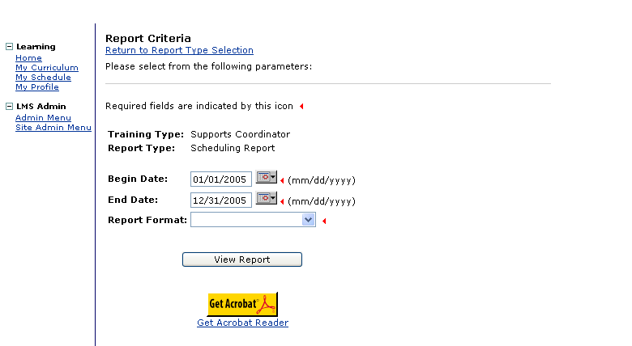

Parameter | Description | Mandatory or Optional
Begin and End Dates | Selecting a begin and end date narrows the search results | Mandatory
Report Format | Select how the report should appear from the list:  Rich text format and Adobe Acrobat (PDF) – display report results with graphics and a user-friendly layout. Plain text – displays report results without graphics and a standard layout | Mandatory

9. User and Roles Report
This report displays the various roles assigned to users by organization, county and entity.

HCSIS roles that can access this report:
- Registrar
- Instructor
- Systems Administrator

Supports Coordination Reports, Continued
The search parameters are:

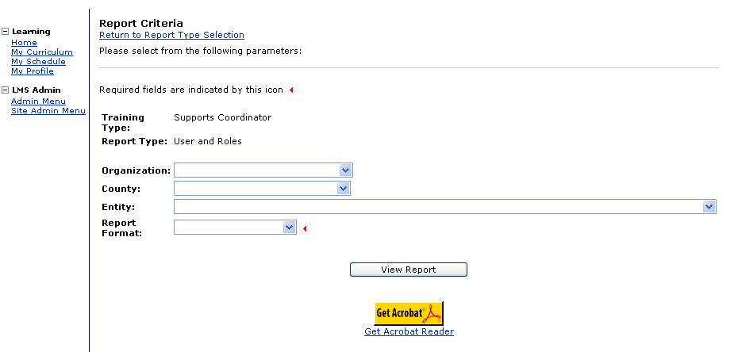

Parameter | Description | Mandatory or Optional
Organization | Select the organization from the drop-down options, if desired | Optional
County | Select the county from the drop-down menu options, if desired | Optional
Entity | Select the entity from the drop-down menu options, if desired | Optional
Report Format | Select how the report should appear from the list:  Rich text format and Adobe Acrobat (PDF) – display report results with graphics and a user-friendly layout. Plain text – displays report results without graphics and a standard layout | Mandatory

You have completed this job aid.

